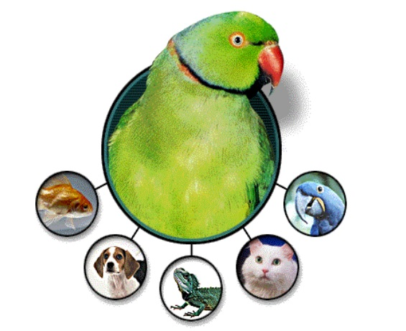  JPS Test plan  Created by Funky QA | Abstract  Details of the testing activities to be done to deliver the Pet Store application.  Funky King  Test Lead

Version History
Version | Date | Changed by | Approved | Changes Made
1.0 | 2022-10-04 | Funky King | Yes | Test Plan Created
1.1 | 2022-10-05 | Funky King | Yes | Formatting optimized
1.2 | 2022-10-15 | Bepo | Yes | Typos fixed

Table of Contents
Version History 1
Introduction 1
1. Testing Objective 1
2. Scope 1
2.1 Features to be tested 1
2.2 Features not to be tested 1
3. Strategy 2
3.1 Methodologies 2
3.2 Approach 2
3.2.1 Execution 2
3.2.2 Automation 2
3.2.3 Defect Tracking 2
3.3 Templates 3
3.3.1 Test Case 3
3.3.2 RTM 4
3.3.3 Trackers 4
3.3.4 Defect Report 5
4. Roles & Responsibilities 6
5. Test Bed 6
6. Risks 6
7. Entry & Exit Criteria 7
8. Schedule and Estimation 7
8.1 Effort Estimation 7
8.2 Schedule 8
9. Deliverables 8

Introduction
This plan is created to give an overview of the scope, methodologies, estimation, and schedule of the testing process for the JPetStore project. The plan will include the features to be tested and not to be tested, types of testing to be done, roles and responsibilities, risk analysis & mitigation plan, time estimation and schedule for the testing to be done.

Testing Objective
Testing will aim to verify the functional and UI aspect of the JPetStore website from the user perspective, in which they will use the application to sign in, browse, and order products from various categories, to guarantee that all the operations work normally in real life.

Scope

2.1 Features to be tested
All the modules that are listed in the functional requirements document will be tested.
- Main Page: UI, sign-in state, product categories, and the links
- Header: Icon links, search bar functionality
- Search Results: Table UI, negative conditions
- Sign In: Register option, signing in
- Register: UI fields, constraints and error messages, account creation
- User Account: User info, user’s orders, info update functionality
- Product Page I: Table UI and fields, item redirection
- Product Page II: Table UI and fields, item redirection, add cart functionality
- Product Profile: Product info fields, add to cart functionality
- Shopping Cart: Table UI and fields, total cost and subtotal calculation, price update, and removing item functionality
- Checkout: Payment form UI and fields, field validation, confirmation pages info, and UI

2.2 Features not to be tested
- Database logic and implementation
- Backend API calls
- Website security and performance

Strategy

3.1 Methodologies
In this QA project, the following testing methodologies will be applied:
- Integration Testing: Related modules tested together
- System Testing: Website end-to-end tested as a whole
- User Acceptance Testing: User-friendliness of the application tested

3.2 Approach

3.2.1 Execution
Testing will be done using a traditional approach to test scenarios and cases. Test case trackers will be created on Google Spreadsheets by the testers and crosschecked. Once done, they will be approved by the Test Lead. After that, the execution will be done by testers each assigned to a different tracker.

3.2.2 Automation
In parallel to the test case execution, every test case will be automated by the SDET team to make the regression testing as well as the system testing cost and time efficient. Cypress (JavaScript) end-to-end testing framework will be used for the automation and the source code will be written via Visual Studio Code. Execution and reporting will be handled by the built-in system of the framework.

3.2.3 Defect Tracking
The below table shows the specifications for the bug triage process.
Attribute | Details
Bug Management System | Jira
Procedure | - Defect found by the tester;  - Reported on Jira using the bug template and assigned to a senior tester;  - Senior tester checked the bug and assigned to the proper developer if there is no concern;  - If there is a fix, the developer assigns the bug back to the QA team;  - Bug Triage meeting is held by the Release Manager for the impact analysis and regression testing;  - Finally retesting and regression testing is done to close the bugs, and not-fixed bugs are assigned back to the developers.  - Process continues till there is no defect left.  - It is up to the development team whether the bugs will be fixed or not, and they can close the bugs without the fix if they decide to do so.
Priorities | P0 – To be fixed immediately  P1 – To be fixed during the release  P2 – To be fixed in later releases
Severities | - Blocker: Cannot proceed with testing without the fix  - Critical: Main functionality does not work  - Major: Functionality does work, but the impact of the bug is uncertain  - Minor: There is no impact on the business, yet there is an error

3.3 Templates

3.3.1 Test Case
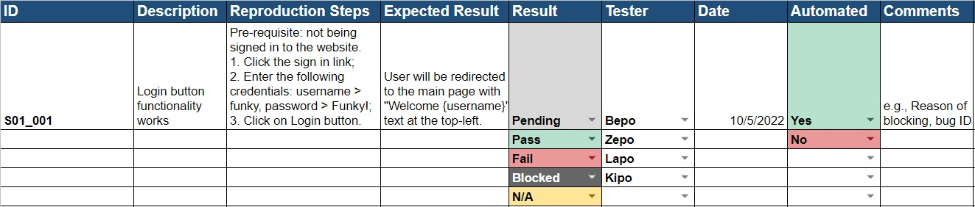

3.3.2 RTM
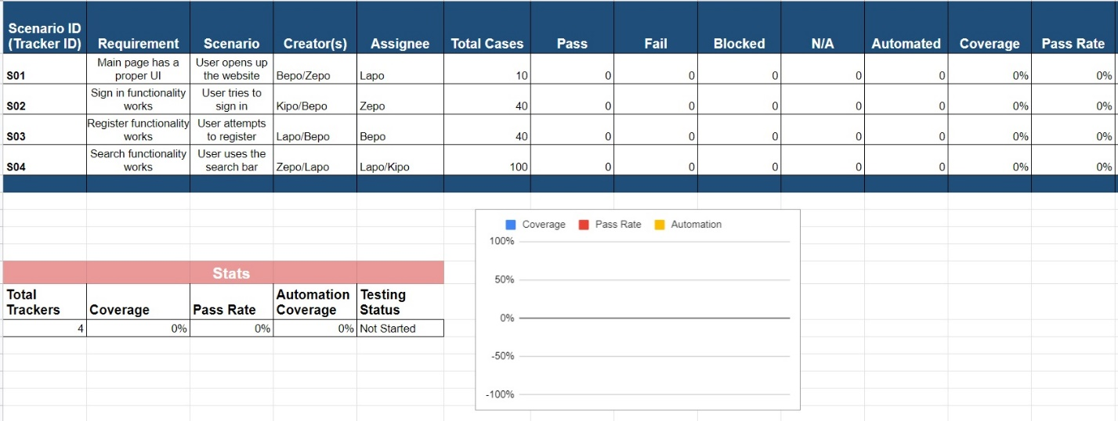

3.3.3 Trackers
Testing Tracker
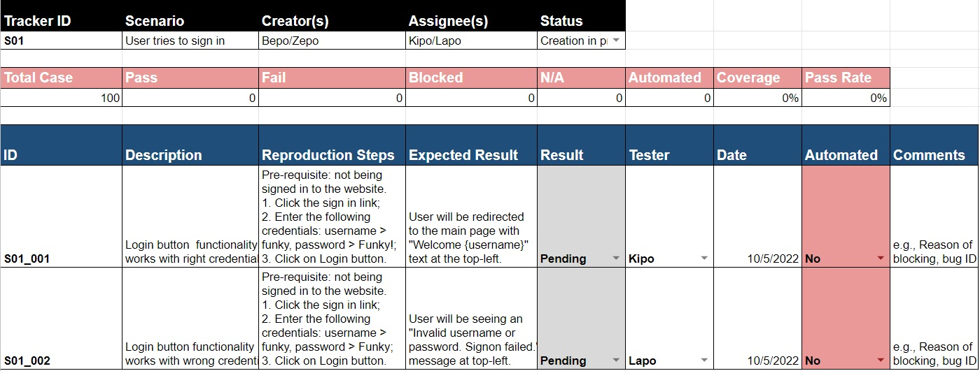
Bug Tracker
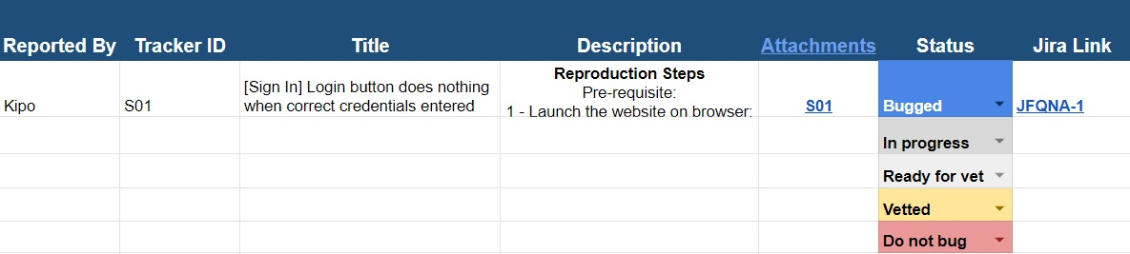

3.3.4 Defect Report

[Module] Type of Issue occurs at the Area of Issue when Circumstance
Reproduction Steps
Pre-requisite:
1 - Launch the website on the browser;
4 - Observe the issue.
Actual Result
A detailed description of the issue. Example:
The login button at the sign-in page does nothing when clicked after entering the correct user credentials
Expected Result
This section can be copied from the tracker. Example:
Please ensure that the login button functionality works with signing in the user and redirecting them to the main page after the correct credentials are given and the button is clicked.
Version
Build number
Reproducibility Rate
e.g., 100%
Priority
One of the following:
P0, P1, P2
Severity
One of the following:
Blocker, Critical, Major, Minor
Additional Notes
A possible reason for the issue, the defect’s importance, impact, etc. Examples:
The cause of the issue might be an error in the script attached to the button.
The issue is a blocker as it affects the testing of the purchase module.
Please note that the login functionality works in the negative case when the wrong credentials are given.
Please see the attached record for reference.

Roles & Responsibilities
Role | Responsibilities
Test Lead (Test Manager) | - Lead and organize the human source  - Communicate with the client about the requirements  - Define the project specifications  - Approve the test trackers
Release Manager | - Identify the test bed needs and set up the environment  - Manage defect tracking procedure  - Prepare release notes
Senior Tester (Test Admin) | - Help other testers with the tasks an environment setup  - Verify the quality of the defect reports  - Prepare the templates and TRM
Testers | - Understand requirements and create test scenarios and cases  - Review the trackers created by other testers  - Execute the test cases and analyze the results  - Report defects on the bug management system appropriately
SDET Team | Develop the end-to-end automation suits

Test Bed

Resource | Description
Hardware | Computer with Windows 10 and 8 GB RAM for each member of the team (7)
Network | LAN network with a speed of at least 50 Mb/s
Server | Web server to run the application

Risks
Assumption | Risk | Mitigation
Testers are familiar with the tools used in the process | New hires are not familiar with the tools | Crash training sessions will be given to the new testers
All test team members will be present till the end of the project | One or more members quits the project before the end | Workload will be divided equally among the other testers
Test and Release managers will carry the project till the end | One of the managers was not able to be on the team | Managers will be borrowed from another team in the company
The team collaborates in all phases with no issue | Conflicts are occurring among team members | A few team-building activities will be held up

Entry & Exit Criteria
Entry Criteria:
- Test plans, templates, and trackers are created and reviewed
- All the team members are familiar with the processes and the requirements
- Environment setup is done for all the members
Exit Criteria
- 100% test coverage must be done unless a clear reason is given.
- 90% pass rate is mandatory, and all the defects above P2 priority must be fixed.

Schedule and Estimation

8.1 Effort Estimation
Task | Assignee | Effort
Tracker Creation | Testers, Senior Testers | 100 hours
Environment Setup | Release Manager | 20 hours
Test Execution  (Including Automation and Defect Tracking) | Testers, Senior Testers, SDET Team, Release Manager | 80 hours
Test Report | Entire team | 16 hours
Test Delivery | Entire team | 24 hours
Total | N/A | 240 hours (6 weeks)

8.2 Schedule
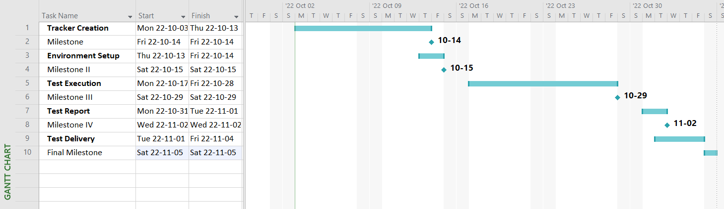

Deliverables

- Before Testing: Test plan document, testing tracker (test cases)
- During Testing: Access to the test management and the defect tracking tool
- After Testing: Test results and reports, defect reports, release notes

